Hamden Public Library
Annual Report: 2013-14

A report of collections, services and activities of Miller Memorial Central Library, Brundage-Community Branch Library and Whitneyville Branch Library from July 1, 2013 to June 30, 2014.
Marian Amodeo, Library Director

Hamden Public Library
  - Annual Report: 2013-14

Personnel

Two new fulltime staff members joined our team- reference librarian Amie Lemire and children’s LTA Denise Martens. LTA Debby Spiegel-Richey marked her 25th year of work here at the Hamden Public Library with a special dinner attended by many staff members.

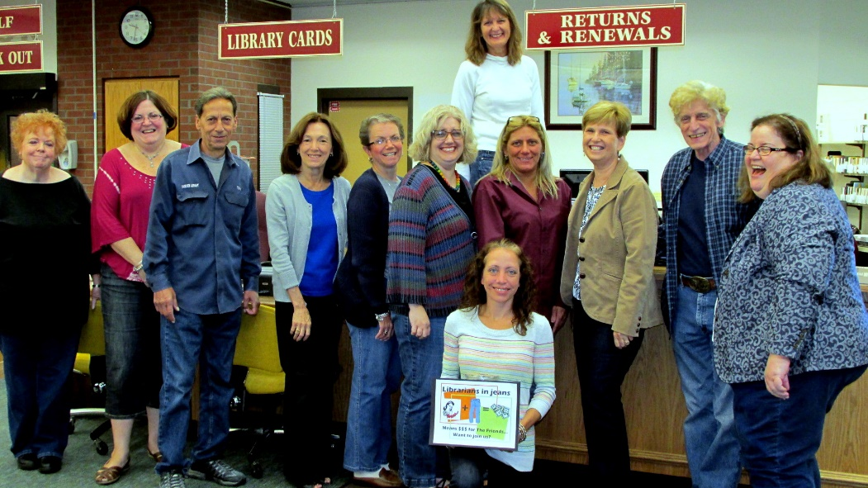
LIBRARIANS IN JEANS: Library staff & patrons willingly paid ‘fines’ for wearing jeans to work. The money collected—over $50—was donated to the Friends of the Library.

Plusses
- Legislative Council approval of LION Consortium membership was some of the biggest news of the year. Planning for migration began immediately. First up was a massive weeding of the collections with a goal of looking back on items that had not circulated for five years or more. We now have a more current, more attractive, more accessible collection as we move into LION, and will have more accurate numbers to work with as we plan the move for all of our collections.

- The other big news during this fiscal year was the awarding of $100,000 to the Library by the Education Department. The inclusion of the public library in the Alliance Grant funding was an amazing gift, and allowed us to begin planning for an expanded Children’s Room.

- The Friends held their quarterly meetings throughout the year. The bookstore, bolstered by a fresh coat of paint and renewed publicity due to attractive new signs in the library, saw brisk business during the year. Because of this, the Friends were able to give the library funding for all autumn and holiday children’s programs at Miller Library as well as the two branches, funding for winter Children’s programs, the first Adult Winter Reading Program, and requests for museum and attraction passes. Within the Friends a hard-working committee spends many months spreading the word among schools about the Wilder Essay Competition. Students from many CT towns vie for cash prizes.
- The branches were the recipients of new public use computers--seven at Community and five at Whitneyville. Licenses for Office 2013 were purchased and installed, much to the delight and relief of library patrons. This was one milestone reached as we attempt to upgrade computers and accompanying technology for our patrons.
- At long last, the Whitneyville Branch parking lot was repaved and expanded. Several spaces were gained, including an extra handicapped space. The sidewalks around the building were also replaced or repaired. A new roof topped it all off.
- The Circulation Department began to roll out newly designed library cards. Cream background with the handsome new green and black logo, they will replace the light blue cards. Also, a bookdrop was installed into the Circulation desk. This has been helpful in keeping the desk cleared of items during busy times.
- Twitter and Facebook continue as our primary social media tools. We now have 785 followers on Twitter as well as 708 ‘likes’ on Facebook. During the year it has become apparent that posting short videos attracts a sharp rise in visits to our pages followed closely by photo postings—particularly those of children. Text-heavy posts receive little attention.
- In June we ventured into the luxury of our first full-color print run for the newsletter in honor of our summer reading program. Approximately 5,000 print copies of the newsletter were distributed throughout the year while we currently have a mailing list of over 1,220 e-newsletter subscribers. Throughout the year we have sent out 55 emails through our Constant Contact subscription which not only allows us to send targeted messages to our subscribers but gives us data on the number that are actually read and/or acted upon (click throughs).
- The Library hosted a Business Before Hours breakfast on November 1 in order for the candidates for local election to meet Hamden Chamber of Commerce members. Over thirty people attended and networked under the rotunda that morning. Generous donations of food and flowers from Eli's and Lucian Florist ensured the success of the morning.
- After fourteen years, Joe Pepe has retired from the Hamden Historical Society Library that is housed here at Miller. Beth Shutts, a retired Cheshire librarian, will replace him. New hours that the room will be open to the public are: Tuesday evenings from 5 to 8 pm, and Wednesdays from 10 am to noon.
- The new wireless network is up and running at the main library. This enhancement has been a long time coming, but it is here and patrons are now able to access the library’s wireless from anywhere in the building.

Programs

2013-2014 saw the advent of major adult programming at Miller library. The fall series of 3 programs attracted a total of nearly 200 people to the events which were alternately held in our rotunda and Thornton Wilder Hall. Our first ever winter reading program for adults- Cabin Fever Readers- had 118 sign-ups with more than 60 actively participating during the 10 weeks the program ran. 51 of the 60 took advantage of the online component of the program which gave them the option of recording their reading progress in the comfort of their own home rather than venturing to the library during inclement weather or its aftermath. In addition, a core group of participants attended a variety of daytime programs offered weekly to pass the long winter hours. Our spring programs included a series focusing on the ‘Staycation’ theme with the final presenter, Jan Mann, attracting the largest audience for her discussion of her book Cruising Connecticut with a Picnic Basket. Other spring programs included a musical presentation by Hiroya Tsukamoto and, by far our biggest draw since the Donald Hall celebration, Pat Wright, The Dog Listener. Pat’s audience of nearly 200 was not disappointed by her informative and entertaining presentation on dog behavior.
Brundage-Community Branch has been the recipient of the Parents and Communities for Kids (PACK) Grant for the past ten years. This grant allows us to have monthly programming for children ages 6-10 and emphasizes family learning experiences outside the classroom. Recently, PACK changed its format. Programs now reflect the focus of three “anchor” organizations which are also PACK recipients: Eli Whitney Museum (building), Yale Center for British Art (Fine Arts) and CT Children’s Museum (Interactive stories and music). Each PACK organization presents four programs within a six month period reflecting these themes. After each event, each family receives a copy of a book about the topic of the night and enjoys a pizza party.
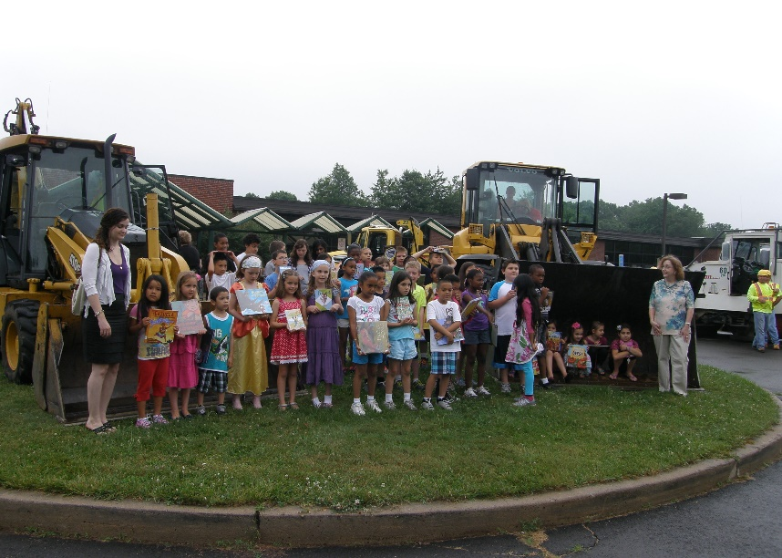

SUMMER READING: Hamden Public Works Department brought out their big machines to entice Dunbar Hill students to “Dig Into Reading” by joining the library’s summer reading program.

At the Miller Library, July is typically the busiest month for programming in the Children’s Room and this year was no exception. The summer reading program theme was Dig Into Reading. 19 programs fashioned around this theme were held for a total of 515 children and caregivers. Highlights included Zoo Station, Compost Stew, Mineral Mania, Wiggle Worms, Dig into Nature, The Scoop on Dirt, and Animal Embassy. 603 children participated in the summer reading program, reading through the last two months, earning prizes and paperback books.
Miller Library offered free computer classes for patrons taught by local businessman Paul Berendsohn. The student demographic was primarily 60+, with a “beginner’s” skill set and familiarity with computers and technology. 120 people took advantage of these classes.
Librarian I Amie Lemire collaborated with Alex Markey, a Case Manager at Hamden Children’s Center, to develop collaborative teen programming. A Teen Creative Writing Group was created. One of the goals of the Creative Writing Group is to create a publication of their written work as well as working on a spoken word/poetry event where they read their work out loud to an audience. Amie gave the group writing homework and also assignments to be complete during the session. Writers voluntarily share their work, and read aloud their poems, short stories, and autobiographical material. Some of their work is very moving. Amie has given an underserved population a voice through this program.
The Hamden Book Discussion Group celebrated its 100th title read by hosting author Sarah Pemberton Strong. The group read her second novel, The Fainting Room, for this landmark occasion. The attendees had the opportunity to discuss with the author her motivations and methods in writing the book. Ms. Strong, a Hamden resident and master plumber, was a delightful guest, cheerfully entertaining all questions from the group. The book discussion group was launched in June, 2004. It continues to meet monthly. Books are selected from titles suggested by group members, library staff members, and review journals. A list of the 100 titles read to date is available at the library.

Problems

- The exteriors of all three Hamden Library buildings are in dire need of repair and attention. The branch libraries need paint and other repairs to the buildings, and the grounds are an embarrassment. The main library needs power-washing of the bricks, landscaping, and other repairs. Other serious building issues include the HVAC system at the Brundage-Community branch that continuously stops working, and other interior problems that have been neglected for a very long time.
- Less than a month before the library was due to migrate to the LION system, our then-current server died. Although we were told that system back-ups were in place at the Government Center, this was not the case. The SirsiDynix Company was forced to try and rebuild our database from the files that had been corrupted by the server crash. Our entire automation system was inoperable for over a week. Basic services were partially restored at the main library, but not at the branches. Staff was forced to manage to keep the operation running until July 22nd when the migration to the new system was completed.
- The library was the unfortunate recipient of damaging publicity as the discovery was made, and then made public, that the entire Miller Complex building had no working fire alarms. A fire watch was begun immediately to ensure everyone's safety, and soon a contract was awarded to a company who succeeded in fixing the problem.
- The library van was out of commission for many weeks at intermittent times during the year. This meant that no delivery of materials among the three libraries was possible while it was in the repair shop. Patrons were inconvenienced and could not get their materials. When deliveries finally began, the work load was challenging. A request for a new or newer van is once again in the capital budget request again this year.
- The new phones that we received long ago but were not hooked up sat around so long that the warrantee expired. Now that we are connected to the town system, there are multiple bugs that need to be worked out.

Planning

Most planning for the year centered around two major areas- the migration to a new automated library system and the cleaning, renovating, moving, and creating new spaces in the Miller Library. Some details include:
LION- Behind the scenes involved setting up loan parameters, display values, and codes. Determinations and decisions regarding bibliographic, circulation, and financial rules needed to be made. Then, extraction of Hamden’s records will begin.
An extensive project of weeding old, outdated, and never-used books from the collection has been a priority for many library staff members for a few months. Staff worked hard on this most important project that a library can do. A healthy collection of books on timely subjects, with up-to-date information, attractive and informative, is the goal as we move to highlight our book collections, for which the Hamden Library has a good reputation. Room has now been made for new and replacement books that will be more accessible to our patrons.
July 22, 2014 is the target date for the Hamden Library to activate the Innovative Interfaces System and officially become members of the Libraries OnLine Inc. (LION) consortium of area libraries.
ALLIANCE GRANT: Library Director Marian Amodeo worked with Hamden’s Purchasing Agent Phil Goodwin to prepare an RFP for design work on an expansion of the Children’s Room.
Much time was spent with design consultant Karen Ribnicky as work was on going on a floor plan for the entire library.

Much needed cleaning of library spaces continues in an orderly and methodical manner. Every nook and cranny of the library needs to be cleaned and cleaned out.
Info staff is getting ready for the move into what was Technical Services. Tech Services staff will move into what was formerly called the Mending Room. Marian will move her office to the second floor, as will Tracy in order to vacate the spaces that will become the Children’s office and Program Room.
Plans for electrical, plumbing, painting, etc. are beginning to be formulated. Target completion is mid to late fall.

Professional Participation

Staff attended workshops on various pertinent topics ranging from genealogy to problem patrons to book repair. Other staff took advantage of the CT Library Association convention to learn about advancing quality digital and media literacy, youth policies and procedure in action, and bullying in the library workplace.
Other workshop attendance included Sharing with Social Media, E-Books 101, and Affordable Care Act Workshop.
A committee of staff members was formed to help create a dress code for the library.
Many staff members visited other LION libraries to meet with their colleagues and learn how the system works and how other libraries set up their functions.
A staff safety committee was established and charged with creating a packet of useful emergency information. The committee invited various guests from the public safety departments to speak at our staff meetings.
Many staff attended a special session of Interlibrary Loan training that a state library staff member taught here at the library. As we changed the way this process is done, and as we brought more staff into the process, training was essential and successful.
The Hamden Public Library was represented at the Earth Day Fair, the High School Career Fair, the Chamber of Commerce Business Expo, and the New Haven Reads Spelling Bee.

Library Usage & Other Statistics

CIRCULATION (CKO & renewals) |  |  | BORROWERS
Miller | 347,544 |  | Resident | 21,361
Whitneyville | 32,465 |  | Non-Resident | 4,604
Brundage | 20,243 |  | Other-(Staff, ILL, etc) | 324
Ebranch (e-book/e-audio) | 13,426 |  | TOTAL | 26,289
TOTAL | 413,678
 |  |  | New borrowers | 1,232
REQUESTS PLACED |  |  | Renewals | 1,941
In Person/Phone | 5,052 |  | HOLDINGS
Online | 17,061 |  | # of Item holdings | 185,260
TOTAL | 22,113
COMPUTER SESSIONS |  |  | CATALOGING STATS
Miller | 20,324 |  | Items cataloged | 16,157
Whitneyville | 3,307 |  | Mended books | 670
Brundage-Community | 3,975 |  | TOTAL | 16,827
TOTAL | 27,606 |  | gifts (included in total) | 1,039
 |  | WEB
Library website page views | 296,170 |  | Twitter Followers | 751
Bookletters Page Views | 13,828 |  | Facebook Friends | 605

